HR ACTIVITIES

 Recruiting: Hiring activities needed to fill vacant positions, include:
 Creating Effective Job Descriptions
 Researching Compensation benchmark & Benefits
 Sourcing Candidates
 Screening Applicants
 Screening Resumes
 Interviewing
 Selecting Candidates
 Hiring

New Hire Orientation
Onboarding Process
Crafting tailored Employee Handbook, including key Policies & Procedures

 Day-to-Day HR Operations: Review HR software needs

 HR Audit & Compliance

Employee Relations & Conflict Resolution

Benefit Administration

Payroll Administration

HR STRATEGIES

Talent Acquisition Services: A more modern, strategic approach to hiring. In addition to traditional recruitment activities, talent acquisition also includes:
 Hiring Planning
 Development a Recruitment Strategy
 Recruitment Marketing
 Onboarding
 Succession Planning (also known as Replacement Planning)

 Company Culture

Leadership Coaching

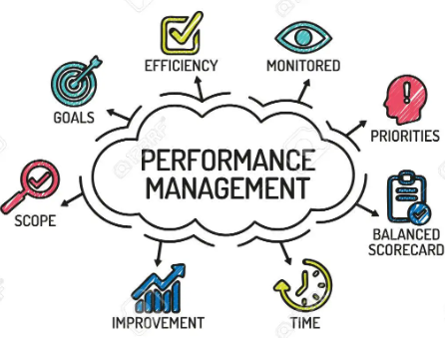Performance Management “Sustaining a high-performance culture”: Deep focus into individual and team development to align employee performance goals with organizational needs and to measure the progress being made towards business objectives. Pillars: (1) Performance Planning (2) Coaching & Feedback (3) Performance check-ins (4) Formal performance reviews (5) 9-box performance X potential matrix

 Talent Management: Ensures an organization has the right supply of talent to achieve its business goals now and in the future. Pillars: (1) Recruitment (2) Learning & Development (3) Performance Management (4) Retention

Company/Department Reorganization

Employee Engagement: “Building a Culture of Recognition”: (1) Stay Interviews (2) Employee Engagement Surveys > Share Results & Insights > Create Action Plans > Develop Managers (3) Recognition Programs

